**LOG MANAGEMENT**

- Every organization has different logging needs

- It should be set up based on requirements.

- Adjust logging to record enough info for issues without slowing the database.

* **Types of Logs:-**

1. Startup and shutdown logs

2. Query logs

3. Query duration logs

4. Error logs

5. Connection and disconnection logs

6. Checkpoint and Write-Ahead Logs (WAL)

* **LOG Management Parameters (Default Values)**

1. logging_collector = on
2. log_destination = stderr
3. log_directory = log
4. log_filename = postgresql-%a.log
5. log_line_prefix = %m [%p]
6. log_hostname = off
7. log_timezone America/Los_Angeles
8. log_connections = off
9. log_disconnections = off
10. log_statement = none
11. log_duration = off
12. log_min_duration_statement = -1

**GENERAL PARAMETERS**

**1 ) logging_collector = on**

-Enables the logging collector process

-Captures log messages and writes them to log files on disk.

1. **log_destination = stderr | syslog | csv | eventlog**

--specifies where PostgreSQL sends its log messages.

--can be sent in below four values

* **stderr**: Logs go to standard error .In the log directory.



* **syslog**: Logs go to the system's syslog service. Logs will go to /var/log/messages

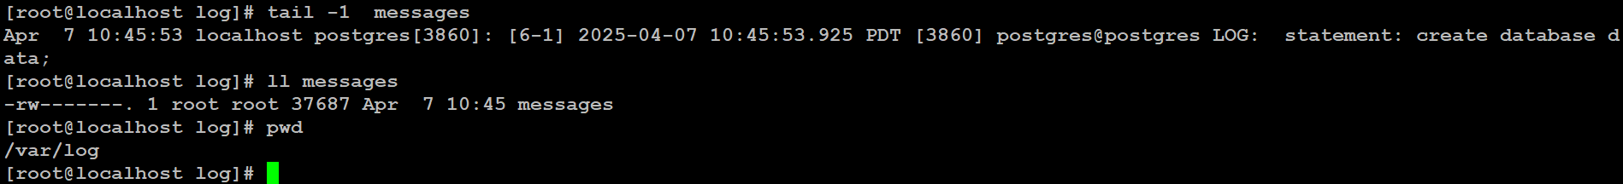

* **csvlog**: Logs are saved in CSV format, useful for analysis tools.



* **eventlog**: For Windows, logs go to the Windows Event Log (Windows only)
* **jsonlog** :- jsonlog is a log format that outputs PostgreSQL logs in structured JSON (version 13 or later)



**3)log_directory = log**

--logs will be saved in a log/ folder inside your PostgreSQL data directory

**4)log_filename = postgresql-%a.log**

--controls the name of the log files PostgreSQL creates.



|  |  |  |
| --- | --- | --- |
| %a | Abbreviated weekday name | Mon |
| %A | Full weekday name | Monday |
| %w | Day of the week (0–6, Sunday=0) | 1 |
| %d | Day of the month (01–31) | 7 |
| %b | Abbreviated month name | Apr |
| %B | Full month name | April |
| %m | Month number (01–12) | 4 |
| %y | Year (2-digit) | 25 |
| %Y | Year (4-digit) | 2025 |
| %H | Hour (00–23) | 15 |
| %M | Minute (00–59) | 30 |
| %S | Second (00–59) | 0 |

--ALTER SYSTEM SET log_filename = postgresql-%a_%d_%b%Y.log;



**5)log_hostname = off (default)**

--we can see the hostname if it is enabled in log_line_prefix

--ALTER SYSTEM SET log_hostname =on;



**6)log_timezone = America/Los_Angeles**

--It sets the timezone displayed in logs

**7)log_line_prefix = %m [%p]**

--information appears at the beginning of each log line

--helps in identifying sessions, users, databases, and much more.



--ALTER SYSTEM SET log_line_prefix = '%t [%p] [%u@%d] ';



--Importat codes

|  |  |
| --- | --- |
| **Code** | **Description** |
| %m | Timestamp (with milliseconds) |
| %t | Timestamp (without milliseconds) |
| %p | Process ID (PID) |
| %u | User name |
| %d | Database name |
| %h | Remote host |
| %a | Application name |

**8)log_connections = off, log_disconnections =off**

--Setting log_connections to 1 will record all authorized connections as well as attempted connections.

--in busy environment, log file becomes flooded with repetitive connection logs, which may impact performance and log readability.

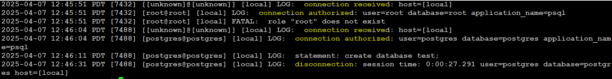

**9)log_statement = none**

-- ddl, mod, all

**--ALL**

-- SELECT, DDL, DML statements

-- Don't use log_statement = 'all' on busy systems, as it would pile up the log

file.It can slow down performance and fill up disk space.

-- it will lead to increase in CPU load

-- impact on DB performance as it can slow down the queries

-- Use 'all' only for debugging or on low-traffic systems.

-- helps to track slow queries

**--MOD**

--Use log_statement = 'mod' to log only changes (INSERT, UPDATE, DELETE,

DDL).

--Best for tracking actual changes

--low impact on performance unless there are huge writes

--slight increase in CPU usage

**--DDL**

-- logs DDL statements(create, alter, drop, truncate)

--minimum impact on performance

**10)log_duration = off**

--if on ,the duration of every completed statement will be logged

--better to keep it off, unless we are trouble shooting performance problems.

--Calculating and recording statement durations makes the database engine do extra work (no matter how small), and when there are hundreds or thousands of queries, the savings can be significant.



**11)log_min_duration_statement = -1**

-- logs slow queries

-- Only statements taking longer than the set value (in ms) are logged

-- setting it to -1, no statements are logged.

-- setting it to 0, all statements are logged

-- alter system set log_min_duration_statement=1000;

(all the statements which takes longer than 1000ms will be logged)



* Using **log_statement** and **log_min_duration_statement** together

--PostgreSQL avoids logging the same query twice.

--So if a statement is already logged due to log_statement, the duration part won't include the query text again.

--You’ll see two separate lines: one for the query itself, and one for the duration

**~ IMPACT:-**

--CPU Usage will be increased.

--Disk I/O is high

-- Log size will increase

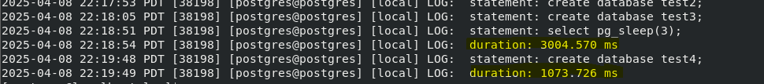

* using it with **log_duration**

-- Use only one of them to avoid confusion.

-- it will log all duration of the queries

**~ IMPACT:-**

--Disk I/O is High

--CPU Usage is increased

--Log Size will increase



**ADDITIONAL PARAMETERS**

**1)log_error_verbosity = default | terse | verbose**

**--default**

-- This parameter controls the amount of information PostgreSQL will record for each event recorded in the log file.

-- Unless debugging a database application, this parameter is best to keep to “**default**”.

**--Verbose**

--The **verbose** mode will be useful when you need to capture the file or function name and the line number there that generated the error.

-- output includes the SQLSTATE error code and the source code file name.

**--terse**

-- Setting this to “**terse**” will suppress logging the query, which may not be useful.

-- itexcludes the logging of DETAIL, HINT, QUERY, and CONTEXT error information.

**2)log_min_messages = WARNING**

-- The log_min_messages parameter determines the minimum severity level for messages to be logged.

-- This controls the verbosity of the logs.

-- various severity levels, are as DEBUG, INFO, WARNING, ERROR, and PANIC.

-- The default is usually WARNING, but you can adjust this based on your needs.

**3)Log_rotation_age = 1**

-- determines the maximum lifetime of an individual log file.

-- A new log file will be created when the amount of specified by log_rotation_age has elapsed since the creation of the previous log file.

-- logging_collector must be enabled

-- A value of 0 disables log_rotation_age

**4)Log_rotation_size = 10MB**

--Sets the maximum size a log file can reach before being rotated

--Set to zero to disable size-based creation of new log files.

**5)log_truncate_on_rotation = on**

--It is used to overwrite existing any log file of the same name instead of appending to the file.

--It is useful when you have a log_filename pattern like postgresql-%a.log

**6)Log_file_mode = 0600**

--The 0600 permission is commonly used for sensitive files that should only be accessible and modifiable by the file's owner.

--With this setting, you can only access, view or modify this file by switching to the postgres user or using root privileges.

**`````````’,**

**Important Configuration Notes**

**--Please note that the 'log_min_duration_statement' parameter does not depend on or interfere with the log_statement parameter.**

**1)No Logs**

log_statement = none

log_duration = off

log_min_duration_statement = -1

**2) Log Query, but no duration**

log_statement = mod

log_duration = off

log_min_duration_statement = -1

**3) Only duration (no use as it will show only duration, no context)**

log_statement = none

log_duration = on

log_min_duration_statement = -1

**4)Slow Queries**

log_statement = none

log_duration = off

log_min_duration_statement = 1000

**5)When we need to log the duration and statement**

1. log_statement = none;

log_duration = off;

log_min_duration_statement = 0;



1. log_statement = all;

log_duration = on;

log_min_duration_statement = -1;

